2nd Agrinio Choral Festival

30 September - 4 October 2021

Application Form

Choir Name :

Contact Person :

Ιδιότητα : | Artistic Director ____  Conductor ____  President ____
Association Name :

Address, website, Facebook, email :

Number of chorists :
Due to covid -19 protocols maximum number of chorists on stage 40
Instruments (if any)
Due to covid -19 protocols maximum number of instrument players on stage 8
Soloists (if any):

Total number of the group (including perfrormes, officials, accompanying persons, drivers etc)
Before arrival a name and rooming list must be sent
Contact Telephone number :
Adress, city, country:
Email :
Web Site (if any) :
FACEBOOK (if any)
Repertoire  Maximum  18 minutes | 1.  2.  3.  4.
Type of Choir | Mixed ___  Children  Youth ___  Female ___  Male ___  Vocal Ensemble ___  Chamber Choir ___  Other_____
Choose your concert dates (you can choose 1 or 2)  *Concerts start at 18.30  Choices are indicative. Final programme will be announced on 25 September 2021 | Friday 1 October 2021 ____________  (Ellinis Theatre Agrinio- open space)  Saturday 2 October 2021 ______________  (Ellinis Theatre Agrinio- open space)  Saturday 2 October 2021 ______________  (Thermo town)
Please include

- Short CV of the Choir
- 3-4 Photos
- Youtube links
- Name list of all participants
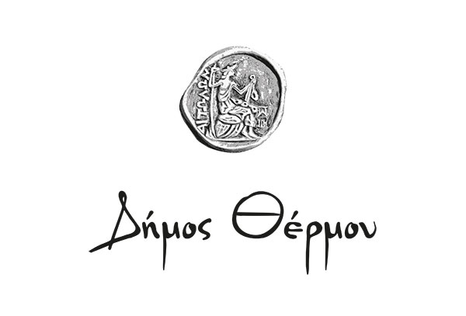
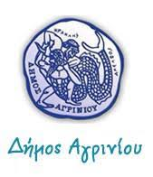

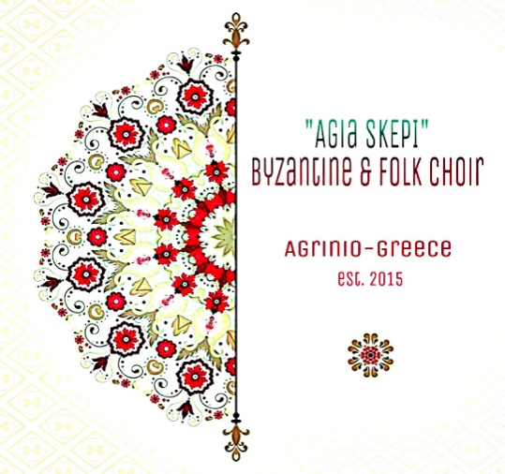
Coordinators




Under auspices

With the Support




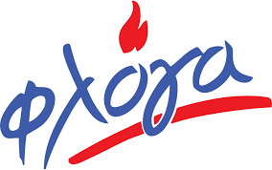
Media Sponsors Επικοινωνίας
Supproting

